**bigdata.io**

**Milestone 1 Part A**

Kyle Domen, Bao Nguyen, Antoine Vo, Ivana Chen, Henri Wood, Sai Manaswini Avadhanam

October 27, 2023

CS 160

Team #2

**Big Data & Analytics**

Your online discussion forum link(discord):

https://discord.gg/Wu8VYtRr

**Contents**

Feature Summary Table 3

Introduction5

Proposed Features 6

Feature #1 Learning modules (Core Requirement C1) 6

How it will be useful to users 6

Why this is Innovative 6

URL References 7

Feature #2 Specialization filtering (Core Requirement C3) 7

Specialization filtering7

How it will be useful to users 7

Why this is Innovative 7

URL References 7

Feature #3 Visual data and interactive modules (Core Requirement C4) 8

Visual data and interactive modules8

How it will be useful to users 8

Why this is Innovative 8

URL References 8

Feature #4 Gamification and progress rewards (Core Requirement c4) 9

How it will be useful to users 9

Why this is Innovative 9

URL References 9

Feature #5 Social media integration (Core Requirement c4) 10

Social media integration10

How it will be useful to users 10

Why this is Innovative 10

URL References 10

Feature #6 Integrated payments for each course (Core Requirement c4) 11

Integrated payments for each course11

How it will be useful to users 11

Why this is Innovative 11

URL References 11

Use Cases 12

Use Case Diagram 22

Site Map Flowcharts 26

# Feature Summary Table

| **Features** | **Why is it useful to users** | **Why is it innovative?** | **Matching core requirement** | **Team Composition** |
| --- | --- | --- | --- | --- |
| 1 Learning modules | Learning modules presents the core learning material to users as they progress through a course. | Modules provide variety of learning content through different mediums and progressive completion to provide a structured, diverse, and interactive experience. | C1 | Antoine Vo |
| 2. Specialization filtering | Users spend minimal time searching for a course, which is needed. | Users may easily identify courses that suit their specific learning objectives without having to go through a large course library. | C3 | Bao Nguyen |
| 3. Visual data interactive modules | User-friendly and engaging interface for interactive learning. Inline code editors for hands-on coding practice. | This feature will provide enhanced user engagement and interactivity. Also, this will bridge the gap between theory and real-world applications. | C3 & C4 | Kyle Domen |
| 4. Gamification and progress rewards | Gamification elements motivate users, making the learning process more enjoyable and helping them track their progress. | Gamification is innovative because it introduces elements like points, badges, and leaderboards to enhance user engagement and provide a sense of achievement. | C4 | Sai Manaswini Avadhanam |
| 5. Social media integration | Collaboration and interaction with friends in the same field. Ability to showcase learning progress on social media. | This feature will provide new ways for users to be motivated as well as creating a sense of community in a topic that they would enjoy learning more about. | C4 | Kyle Domen |
| 6. Integrated payments for each course | Flexibility between professionals and beginners and personalized learning, as well as saving time. | Allows for a La Carte model for choosing and paying for individual items. | C3 and C4 | Ivana Chen |

###### Introduction

Every day, we create an enormous amount of data - things like text messages, photos, videos, online searches, and even the temperature in different parts of the world. This data is so massive that it's like an ocean.

Now, think about having a magical way to collect and make sense of all that information. That's what we call "big data and analytics."

"Big data" means we're dealing with a lot of information, much more than we could ever process by hand. It's like having a huge jigsaw puzzle, one that’s the size that is impossible to do by yourself.

"Analytics" is the set of tools and techniques that help us make sense of this huge amount of data. Things like trying to find patterns, trends, and hidden secrets in that sea of information.

In simple terms, big data and analytics is all about turning the overwhelming amount of data in our world into valuable insights and knowledge.

Our team plans on providing a simple, efficient, and effective online platform to learn more about this growing field. These resources include:

1. **Interactive training modules** and hands-on ways to get you going and make you better in analytics and data science.
2. **Relatability** to users and their interests in order to encourage continuous growth and progress through the field of big data and analytics.
3. **Fully integrated environment** to keep a simple, yet clean, platform that provides everything you need in one space.
4. **Learn what you want to learn** and focus on your interests without wasting time on topics that you’re not interested in or already know.
5. **Notify your peers around you** through social media applications to promote collaboration and a community around your learning.

# Proposed Features

## Feature #1 Learning modules (Core Requirement C1)

1. Course Modules that categories topics to explore under a course.
2. Each module consists of multiple submodules to be completed.
3. Submodules contain multimedia learning content including quizzes, text contents, video contents, and interactive data modules.
4. Completion of all sub modules completes a module.
5. Completion of all modules completes a course.

### How it will be useful to users

1. Learning modules provide the core contents of the site and a structured way to view course contents
2. Progressively unlocked content - ensuring a sequential learning progression that makes sense based on the content a user has mastered.
3. Modules contain a variety of multimedia and rich learning content - including videos from subject experts, text contents, interactive data visualizations, and quiz contents.
4. Variety of contents fosters diverse learning methods and a well-rounded education while improving user engagement.
5. Modules also provide users a measurable sense of progression as they continue through the course and the ability to see the scope of a course.

### Why this is Innovative

Learning modules are a core feature of any learning platform. Pure website takes learning modules a step further by moving away from heavy textbook style modules and more towards interactive modules that is more close to what a user can expect in the big data / analytics industry.

The quality and content from our learning modules will be created and curated by industry experts from the ground-up, rather than replication of existing texts.

As the content relates to big data and analytics, our course will have feature rich visualizations and data modules that will be tailored to our courses subject matters.   
  
Gated modules and submodules that are unlocked through progression ensures mastery of contents before progressing through, allowing users to work at a pace that is comfortable and allowing them to review and master subjects and concepts that build upon each other.

### URL References

URL: <https://www.udemy.com>

## Feature #2 Specialization filtering (Core Requirement C3)

**Specialization filtering**

i. Specialization Filtering allows users to focus on particular subjects or themes of interest and limit down the course catalog.

### How it will be useful to users

i. Users may easily identify courses that suit their specific objectives.

ii. It also aids in the discovery of niche topics that might otherwise get lost in a broad course catalog.

### Why this is Innovative

i. Because users don't have to search through a large course catalog to find courses that meet their specific learning objectives.

ii. This feature can be further enhanced using AI-based recommendations, where the system suggests specializations based on the user's past behavior or preferences.

### URL References

### <https://www.linkedin.com/jobs/search/>

## Feature #3 Visual data interactive modules (Core Requirement C4)

*Visual data interactive modules*

* 1. Bridge the gap between theory and real-world application
  2. Inline code editors for hands-on coding practice
  3. Interactive data visualizations for better data comprehension
  4. Multimedia content, including videos and animations
  5. Represents an innovative and modern approach to online education

### How it will be useful to users

* 1. For abstract and technical topics, such as Big Data & Analytics, it is difficult to see the correlation between theory and practice. Making modules visual and interactive is very important to users because it transforms an online learning environment into a space where engagement is key.

### Why this is Innovative

Visual data interactive modules break away from traditional, passive learning methods, such as reading from textbooks or listening to university lectures, and opens the idea that personal interaction is where learning takes place. Interactive elements, like inline code editors and integrated data visualizations elements, allow users to experiment with code first-hand and witness immediate results based on their changes. Instead of simply reading about certain topics, this fosters a deeper understanding of the subject matter. For example, if a user is coding, they would even be able to see errors in real-time, understanding their faults and providing a learning experience that reinforces what they should do next time. Making mistakes and debugging code is an integral part of learning about big data and computer science as a whole.

Everybody has their own unique learning styles, and bigdata.io accommodates both text-based learning as well as visual learning by providing video content to ensure that all users grasp the information in front of them. Having visual data interactive modules signifies our dedication to adapting an innovation and modern approach to learning in an online space. By breaking away from traditional methods of learning attracts those looking for a more effective learning experience.

### URL References

[Datacamp](https://www.datacamp.com/) (https://www.datacamp.com/)

## Feature #4 Gamification and progress rewards (Core Requirement C1)

### How it will be useful to users

Encourages user engagement and motivation by turning learning into a game-like experience Provides a sense of accomplishment and recognition for completing tasks and achieving milestones Fosters healthy competition and a sense of community among learners Incentivizes users to actively participate in the platform

### Why this is Innovative

Gamification is a powerful tool and strategy to enhance user engagement and motivation. By implementing a merit point system, achievement badges, and rewards, bigdata.io creates a dynamic and interactive learning environment. Users can track their progress, share progress with others, and earn recognition for their achievements. This not only makes learning more enjoyable but also promotes a sense of accomplishment, which is valuable for user retention and long-term learning success.

Offering rewards and discounts for active and engaged users can also provide a benefit for their commitment to learning. This innovative approach adds a layer of excitement and competition to the learning process, making it more engaging and enjoyable to learn for users.

### URL References

[eBay Feedback Forum](http://pages.ebay.com.au/services/forum/feedback.html) (http://goo.gl/3C6zi)

## Feature #5 Social media integration (Core Requirement C1)

*Social media integration*

* 1. User account connection to social media platforms
  2. Ability to showcase learning progress on social media
  3. Collaboration and interaction with peers interested in the same field of study
  4. Content sharing and networking through social media and its connections

### How it will be useful to users

* 1. Fosters a sense of community among learners of big data & analytics
  2. Encourages knowledge sharing and open discussion
  3. Help users stay motivated and accountable for their learning progress
  4. Expands users’ professional networks

### Why this is Innovative

In the context of many fields, including big data & analytics in computer science, networking with professionals is crucial. Allowing users to connect their social media accounts will provide an opportunity to connect with experts, mentors, and peers, providing a space for networking in a virtual world. This feature will mirror networking abilities of the real-world industry connections but in a larger reaching space.

In addition to providing a networking platform, it also provides the opportunity to showcase their learning progress. It enables users to share their learning achievements, creating a motivating factor as they strive to impress and inspire their social network with their data-related accomplishments. Instagram, Facebook, Twitter, is an engaging platform by nature. By participating in discussion about the topic they’re learning about, it will enhance the overall learning experience, making it more captivating and relatable to the modern user. Catering to digital habits and relating to social media is an indication that bigdata.io is listening to modern trends and innovating towards the future.

### URL References

[Pinterest Sharing Element](https://www.pinterest.com/) (https://www.pinterest.com/)

## Feature #6 Integrated payments for each course (Core Requirement C3/4)

Integrated Payments for each course

* 1. User has the ability to purchase more courses with a integrated payment system
  2. A new account will have nothing in their cart
  3. When a user chooses to purchase a course, it can be added to their cart
  4. A user can proceed to purchase the course from their cart and unlock all features in the purchased course.

### How it will be useful to users

* 1. Professionals can pay for a more advanced version of each course
  2. Users would save time and not have to worry about switching between different systems
  3. Personalized Learning

### Why this is Innovative

It is innovative because it allows a convenient and flexible experience for all levels of users. Beginners can dabble in free courses and see which one suits their needs the best. As users progress in their knowledge and skills, they may choose to enroll in more advanced courses because the paid course caters to their specific needs and interests. Likewise, if a user frequently purchases content related to a specific topic, the system can use that knowledge to recommend more content in that area.

Moreover, by utilizing an integrated payment for each course, instead of committing to a subscription package, users are provided with more flexibility over what they pay for, as they can shape their own learning path to better align with their needs. This would allow users to only pay for what they want, allowing for more accessibility to people who may not be able to afford a full subscription, or allow for users to branch out from a one-size-fits-all subscription package.

**URL References**

https://www.edx.org/

# Use Cases

| Use Case ID | UC-1 |
| --- | --- |
| Use Case Name | Learning modules |
| Created By | Antoine Vo |
| Actor | User |
| Description and Event Flow | A registered user signs up for a course. Link to the course presents a progression of learning modules in the order to be learned.  Learning module #1 is initially unlocked. When a user completes a learning module, the subsequent learning module is unlocked, guiding the user through progression of content.  Modules consist of multiple submodules. A submodule can come in a variety of contents - including video content, text content, and interactive charts in order to foster diverse learning methods and a well-rounded education. |
| Pre-Conditions | * Active and registered user account * User has course access |
| Post-Conditions | * Access to modules through the courses page * Module completion upon completion of all sub-modules * Course completion upon completion of all modules |
| Input | * Text module - Next button input to mark as completed * Video modules - Embedded video * Quiz Modules   + Multiple choice input fields   + Number / Text answer input fields   + Code markdown input fields   + Submit button to grade quiz * Data and analytics modules   + Interactable charts   + Table input fields |
| Output | * Modules are marked as completed when finished * Text module is marked completed when next button is clicked. * Quiz modules   + graded based upon click of submit button.   + Quiz is graded based on quiz input responses.   + Module is marked completed if user receives a score above 80% * Video modules are marked completed after x minutes watched. * Data and analytics modules   + Table input fields updates render of data visualizations   + Charts and graphs are updated in time after interaction of input fields. |
| Includes |  |
|  |  |
| Notes | As the site will be coded in javascript, some modules may have scripted content. |

| Use Case ID | UC-2 |
| --- | --- |
| Use Case Name | Specialization filtering |
| Created By | Bao Nguyen |
| Actor | User |
| Description and Event Flow | Specialization Filtering enables users to narrow down the course catalog by concentrating on certain topics or themes of interest.  It is simple for users to choose courses that meet their unique goals.   * Additionally, it helps uncover specialized subjects that may otherwise be overlooked in a large course catalog. * Because courses that match users' particular learning objectives may be found without them having to comb through a vast course library. * AI-based suggestions, in which the system makes recommendations for specializations based on the user's historical behavior or preferences, can further improve this functionality. |
| Pre-Conditions | * Users who have an account or not can also use search filtering. * Search course needed. |
| Post-Conditions | * Users have access to search course filtering. |
| Input | Following:   * Users can search any course then click the filter button to easily find information needed. |
| Output | * List of sequential courses that the user needs to search for. |
| Includes | N/A |
| Notes | N/A |

| Use Case ID | UC-3 |
| --- | --- |
| Use Case Name | Visual data interactive modules |
| Created By | Kyle Domen |
| Actor | User |
| Description and Event Flow | A user works through one of the learning modules provided by bigdata.io. While working through the lessons and learning, the user will be able to use the inline code editor once prompted, and play videos that are available to the user if the lesson provides such video. When the user codes using the inline code editor, they will hit “run” and be able to immediately see the output of their code in real-time and show bugs/errors if present. |
| Pre-Conditions | * A new user is created or a user exists * Enrolled and paid for the course of their interest |
| Post-Conditions | * Users see the output of their code * Users can share to social media once gratified with their progress |
| Input | One of the following:   * User codes using inline code editor in browser * User watches lesson video provided by bigdata.io mentors * User experiment with graphical elements and interfaces |
| Output | One of the following:   * Data/information generated by user code is displayed visually in real-time * Bugs/errors will be shown if user code is not correct * Graphs/table will change in real-time based on how the user interacts with the code after initial code is ran * Share to social media button will be present when the user successfully finishes a code segment, lesson, module, etc. |
| Includes |  |
| Notes | Depending on the subject material and depth of progress in the lesson module, inline code editors and videos may or may not be present. Maybe at the point of where the user is in the lesson, an inline code editor or video is not appropriate or is not needed. |

| Use Case ID | UC-4 |
| --- | --- |
| Use Case Name | Gamification and progress rewards |
| Created By | Sai Manaswini Avadhanam |
| Actor | User |
| Description and Event Flow | * Using the bigdata.io platform, a user progresses through learning modules and other instructional materials. * The user receives virtual badges or awards as they advance, meet required milestones, or finish modules. * Points, badges, leaderboards, accomplishment levels, and other gamification components are added to the learning process to entice and excite the user. * After finishing courses, achieving important academic milestones, or proving their mastery of particular skills, users may be rewarded with certificates or digital credentials. * On their profile page, the user can monitor their progress and view the badges and rewards they have received. * Quizzes, challenges, and other interactive components that make learning more enjoyable and engaging are examples of gamification aspects. |
| Pre-Conditions | * Currently active and registered bigdata.io user account. * interaction of users with the platform's learning activities and modules. |
| Post-Conditions | * Members have accumulated virtual awards or badges that they can show off on their profile. * As a reward for their accomplishments, users can obtain digital credentials or certificates. * Gamification components motivate and engage users in the learning process. |
| Input | * User's progress and interaction with the educational materials. * accomplishment of particular goals, tasks, or problems. |
| Output | * The user receives virtual badges or awards. * The user may receive certificates or digital credentials after finishing a course or reaching a particular level of expertise. * A user's profile page shows the awards and badges they have achieved. |
| Includes | To increase user engagement, gamification features have been incorporated into the platform and learning courses. |
| Notes | Gamification has the potential to be a potent tool for encouraging users to interact with instructional materials, monitor their progress, and cooperate or compete with other members of the learning community. Gamified components are intended to increase user enjoyment and motivate users to establish and meet their learning objectives. |

| Use Case ID | UC-5 |
| --- | --- |
| Use Case Name | Social media integration |
| Created By | Kyle Domen |
| Actor | User |
| Description and Event Flow | User creates an account and progresses through the learning modules with the visual data interactive modules. Once satisfied with their work and wants to share, the user clicks on the “Share” button located on the page. This redirects the user to their desired social media platform and can post from there |
| Pre-Conditions | * A new user is created or a user exists for bigdata.io * The user has a social media account that exists already   + Instagram, Facebook, Twitter, etc. |
| Post-Conditions | * Users can see their bigdata.io progress post on their social media platform * Users’ friends/followers can comment/discuss on the post that is from bigdata.io |
| Input | One of the following:   * User presses the “Share to” button on bigdata.io   + User decides to share to Instagram   + User decides to share to Facebook   + User decides to share to X (Twitter) |
| Output | * “Successfully shared!” screen page will launch on bigdata.io * Posts will be shared on their Instagram, Facebook, X (Twitter) account for their friends/followers to see * If friends/followers/networking partners decide to comment or collaborate based on their post hosted by bigdata.io, DMs will come through their used social media platform |
| Includes |  |
| Notes | All discussions that take place after the link redirect to share will not take place on the bigdata.io platform. It will be hosted by the social media platform that the user decided to share to. |

| Use Case ID | UC-6 |
| --- | --- |
| Use Case Name | Integrated payments for each course |
| Created By | Ivana Chen |
| Actor | User |
| Description and Event Flow | 1. User is presented with a summary list of courses available to purchase.  2. User select the course of interest from the list to add to a cart  3. User confirms all courses in shopping cart are desired and proceed to checkout  4. User enters the necessary payment method  5. User is presented with a confirmation message of the purchase courses and has the option to either purchase more courses or quit the purchase process. |
| Pre-Conditions | * A new user is created or a user exists for bigdata.io * User has a valid payment method (e.g. credit card, debit card) |
| Post-Conditions | * Users can access the newly purchase course |
| Input | * Available courses for user to purchase * A cart to hold the desired courses to be purchased |
| Output | * “Successfully purchased!” screen page will launch on bigdata.io * Course is available to view by the user |
| Includes |  |
| Notes | User has privilege to purchase any number of courses that they want. |

# Use Case Diagrams

**Feature 1: Learning modules**

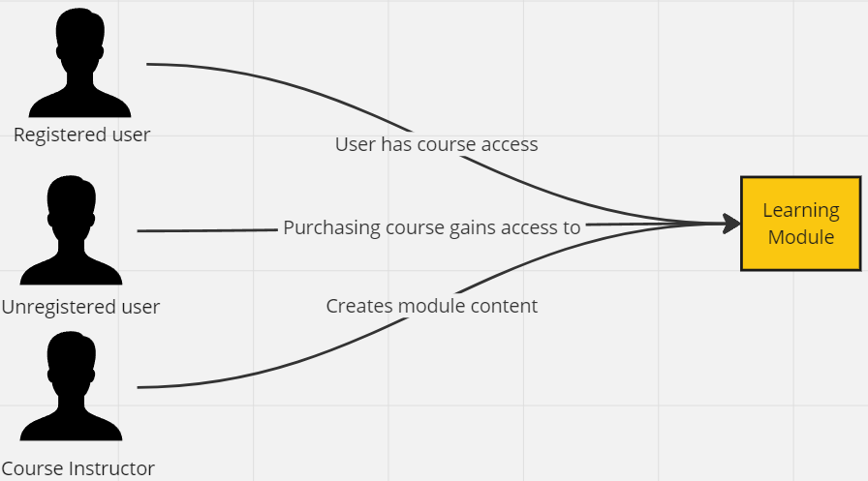

**Feature 2: Specialization filtering**

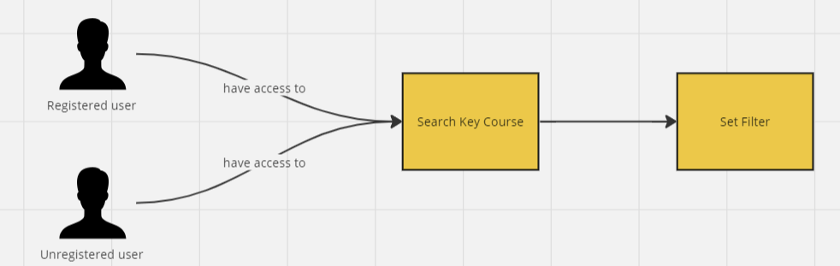

**Feature 3: Visual data interactive modules**

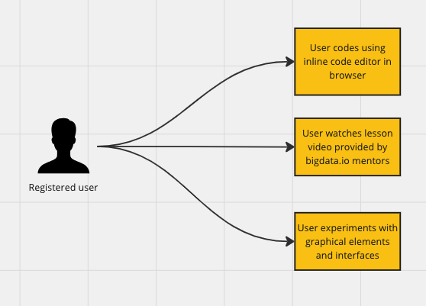

**Feature 4: Gamification and progress rewards**

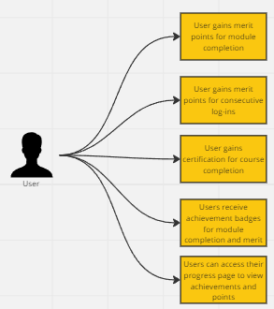

**Feature 5: Social media integration**

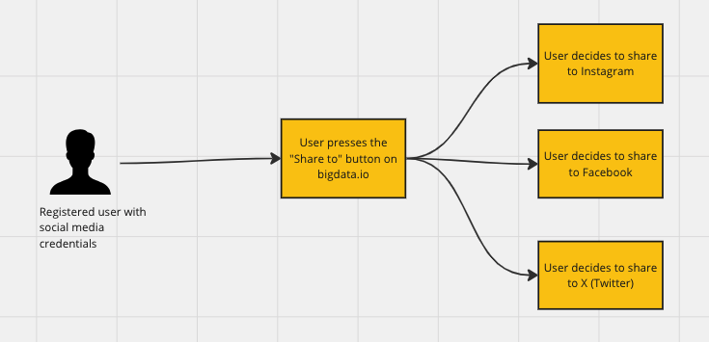

**Feature 6: Integrated payments for each course**

# 

# 

# 

# 

# 

# 

# Site Map Flowcharts

